Java Tutorial
Our core Java programming tutorial is designed for students and working professionals. Java is an object-oriented, class-based, concurrent, secured and general-purpose computer-programming language. It is a widely used robust technology.

Java Tutorial
Our core Java programming tutorial is designed for students and working professionals. Java is an object-oriented, class-based, concurrent, secured and general-purpose computer-programming language. It is a widely used robust technology.

Application
According to Sun, 3 billion devices run Java. There are many devices where Java is currently used. Some of them are as follows:
- Desktop Applications such as acrobat reader, media player, antivirus, etc.
- Web Applications such as irctc.co.in, javatpoint.com, etc.
- Enterprise Applications such as banking applications.
- Mobile
- Embedded System
- Smart Card
- Robotics
- Games, etc.

Types of Java Applications
There are mainly 4 types of applications that can be created using Java programming:

1) Standalone Application
Standalone applications are also known as desktop applications or window-based applications. These are traditional software that we need to install on every machine. Examples of standalone application are Media player, antivirus, etc. AWT and Swing are used in Java for creating standalone applications.

2) Web Application
An application that runs on the server side and creates a dynamic page is called a web application. Currently, Servlet, JSP, Struts, Spring, Hibernate, JSF, etc. technologies are used for creating web applications in Java.

3) Enterprise Application
An application that is distributed in nature, such as banking applications, etc. is called an enterprise application. It has advantages like high-level security, load balancing, and clustering. In Java, EJB is used for creating enterprise applications.

4) Mobile Application
An application which is created for mobile devices is called a mobile application. Currently, Android and Java ME are used for creating mobile applications.

There are 4 platforms or editions of Java:

1) Java SE (Java Standard Edition)
It is a Java programming platform. It includes Java programming APIs such as java.lang, java.io, java.net, java.util, java.sql, java.math etc. It includes core topics like OOPs, String, Regex, Exception, Inner classes, Multithreading, I/O Stream, Networking, AWT, Swing, Reflection, Collection, etc.

2) Java EE (Java Enterprise Edition)
It is an enterprise platform that is mainly used to develop web and enterprise applications. It is built on top of the Java SE platform. It includes topics like Servlet, JSP, Web Services, EJB, JPA, etc.

3) Java ME (Java Micro Edition)
It is a micro platform that is dedicated to mobile applications.

4) JavaFX
It is used to develop rich internet applications. It uses a lightweight user interface API.

Creating Hello World Example
Class simple{
Public static void main(string args[]){
System.out.printIn(“Hello World”)
}
}

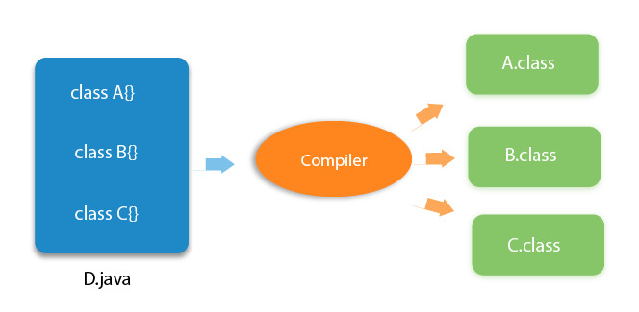

Operator Type | Category | Precedence
Unary | postfix | expr++ expr--
Unary | prefix | ++expr --expr +expr -expr ~ !
Arithmetic | multiplicative | * / %
Arithmetic | additive | + -
Shift | shift | << >> >>>
Relational | comparison | < > <= >= instanceof
Relational | equality | == !=
Bitwise | bitwise AND | &
Bitwise | bitwise exclusive OR | ^
Bitwise | bitwise inclusive OR | |
Logical | logical AND | &&
Logical | logical OR | ||
Ternary | ternary | ? :
Assignment | assignment | = += -= *= /= %= &= ^= |= <<= >>= >>>=

